# 02. Historic Events

**Environment Specifics**

Please be aware that every JS environment may **behave differently** when executing code. Certain things that work in the browser are not supported in **Node.js**, which is the environment used by **Judge**.

The following actions are **NOT** supported:

* **.forEach()** with **NodeList** (returned by **querySelector()** and **querySelectorAll()**)
* **.forEach()** with **HTMLCollection** (returned by **getElementsByClassName()** and **element.children**)
* using the **spread-operator** (**...**) to convert a **NodeList** into an array
* **append()** (use only **appendChild()**)
* **prepend()**
* **replaceWith()**
* **replaceAll()**
* **closest()**
* **replaceChildren()**

If you want to perform these operations, you may use **Array.from()** to first convert the collection into an array.

**Use the provided skeleton to solve this problem.**

**Note**: You **can't** and you have no permission to **change** directly the given HTML code (index.html file).

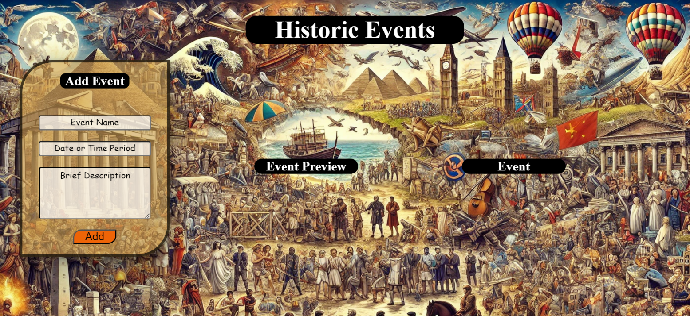

# Your Task

* **Write the missing JavaScript code** to make the **Historic Events** application work as expected:
  + **Event Name, Date or Time Period,** and **Brief Description** should be **non**-**empty** **strings**. If any of them are empty, the program should not do anything.

# Getting the information from the form

* When you click the [Add] button, the information from the input fields must be added to the **<ul>** with the **id "preview-list"**.
* The input fields should then be cleared, and the [Add] button must be **disabled**.
* At the same time the **[**Edit] and the **[**Next] buttons must be **added**.
* The HTML structure should look like this:

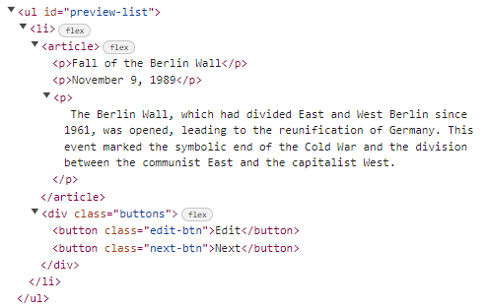

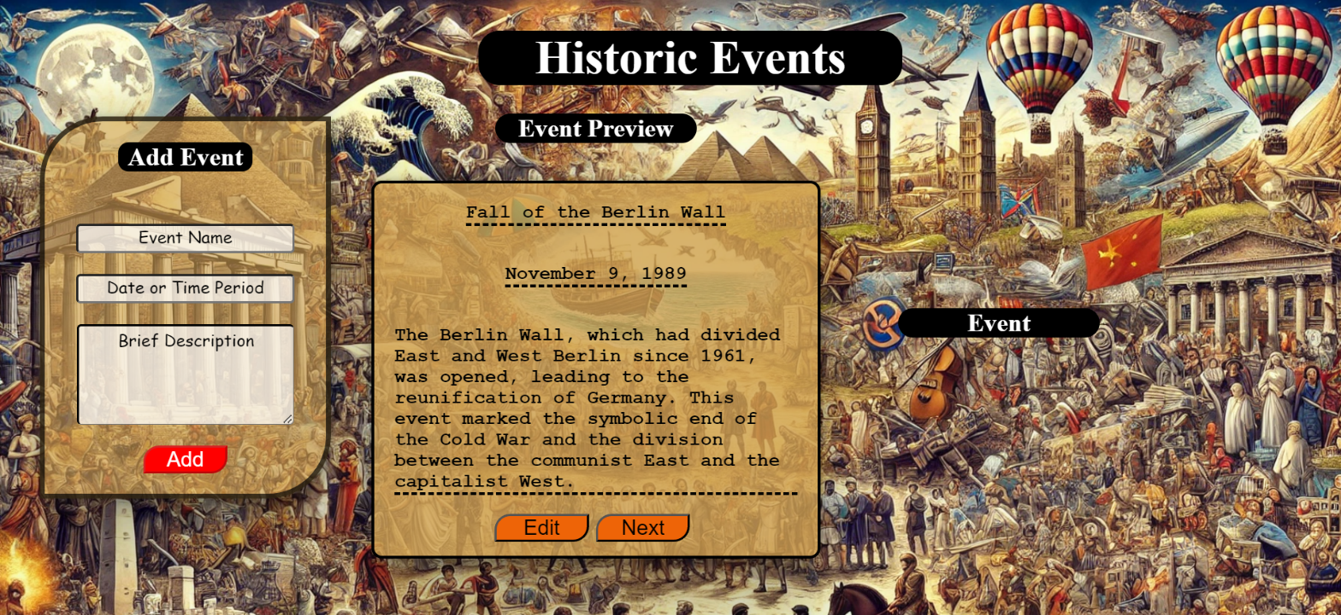

# Edit Info

* When the **[Edit]** button is clicked, the information from the **Event Preview** must be sent to the input fields and the record should be deleted from the <ul> "preview-list".
* [Add] button must be **enabled** again.

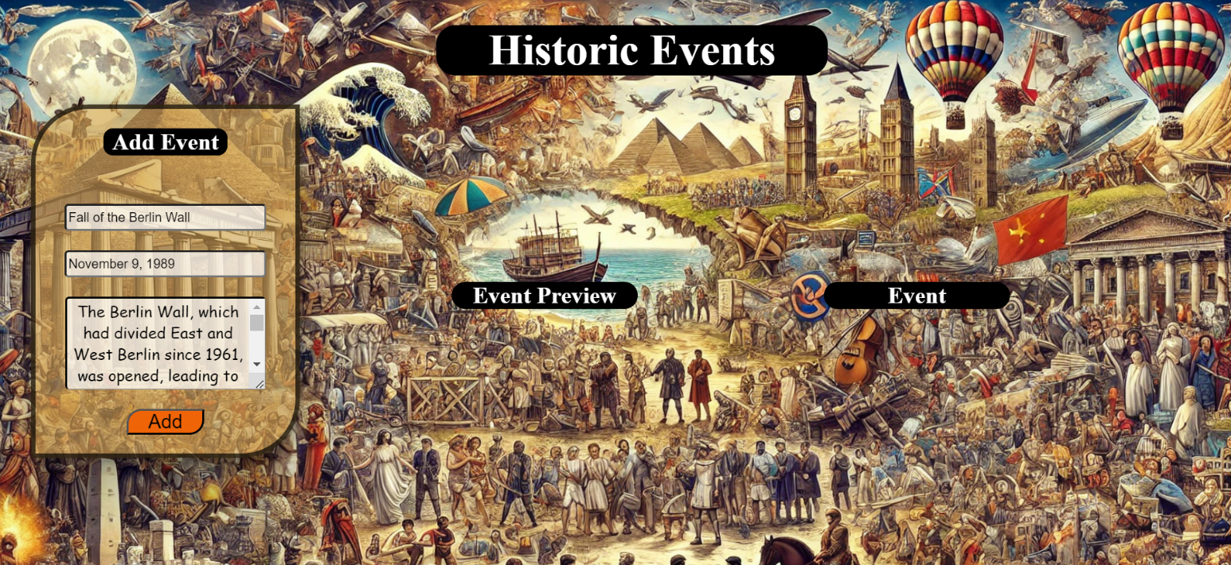

* After editing the information, add a new item to the <ul> with the updated information.

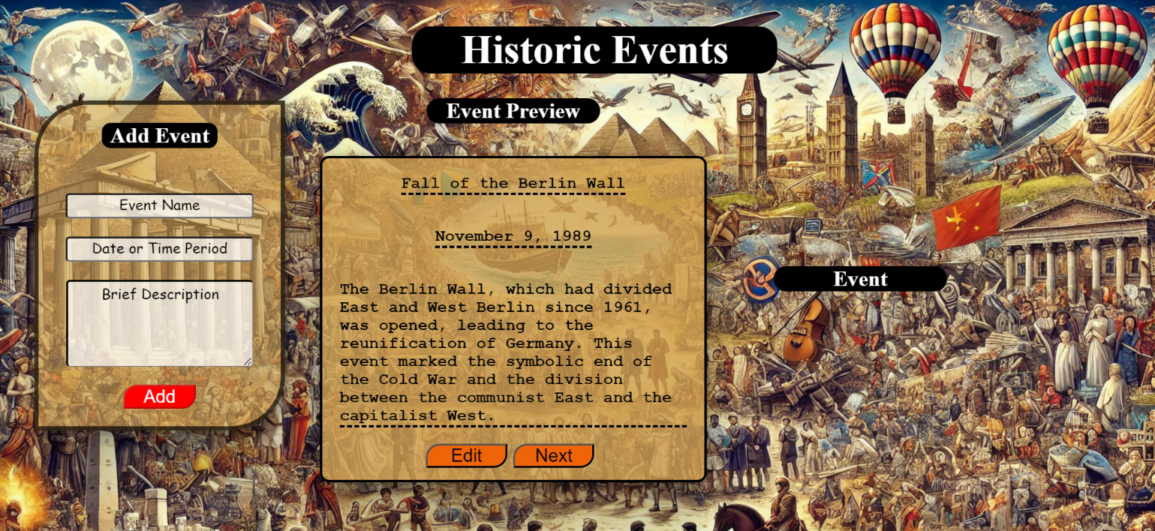

# Next

* When you click the **[Next]** button, the record must be **deleted** from the <ul>withid"preview-list" and appended to the <ul> with id "archive-list".
* The **buttons [Edit]** and **[Next]** should be removed from the <li> element and the **button [Archive]** shoud be added.
* The HTML structure should look like this:

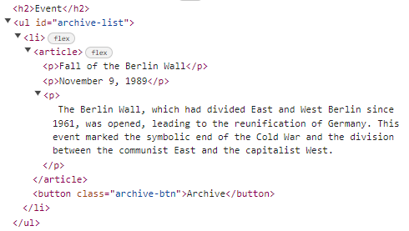 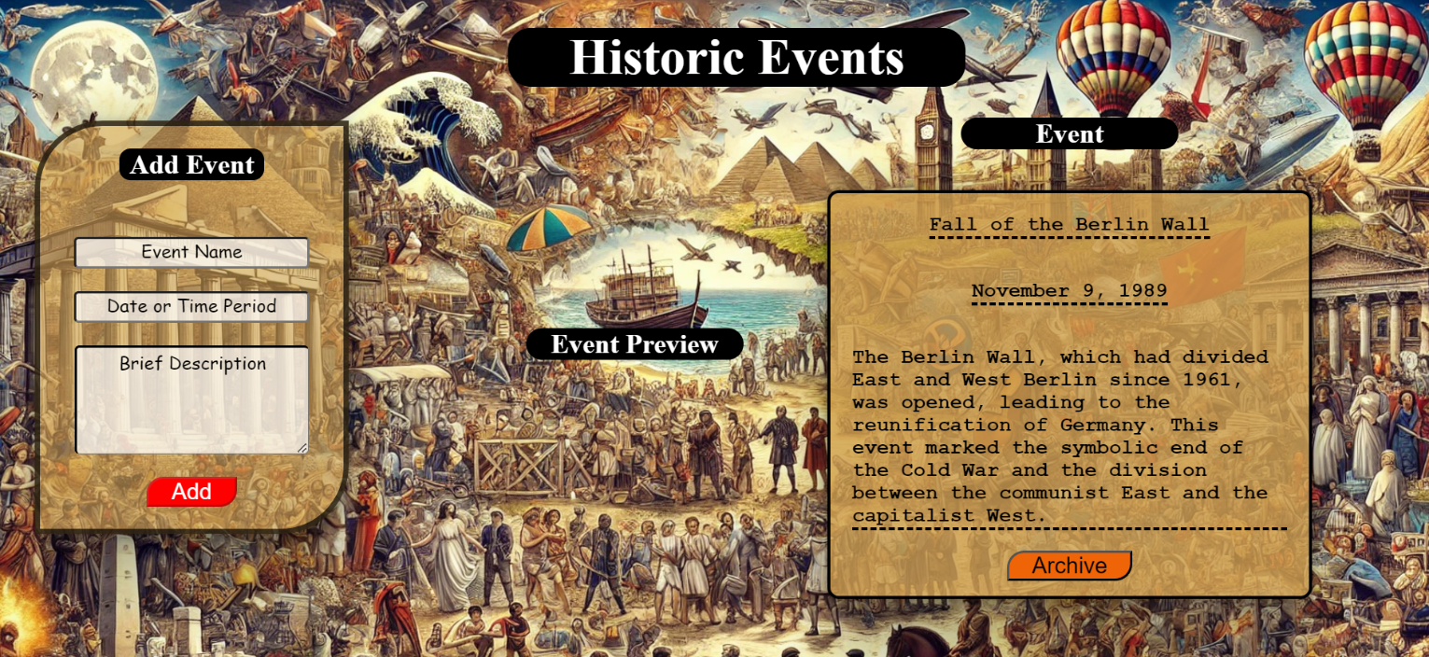

# Archive Event

When you click the **[Archive]** button, the record must be **deleted** from the <ul>withid"archive-list" .

* [Add] button must be **enabled** again.

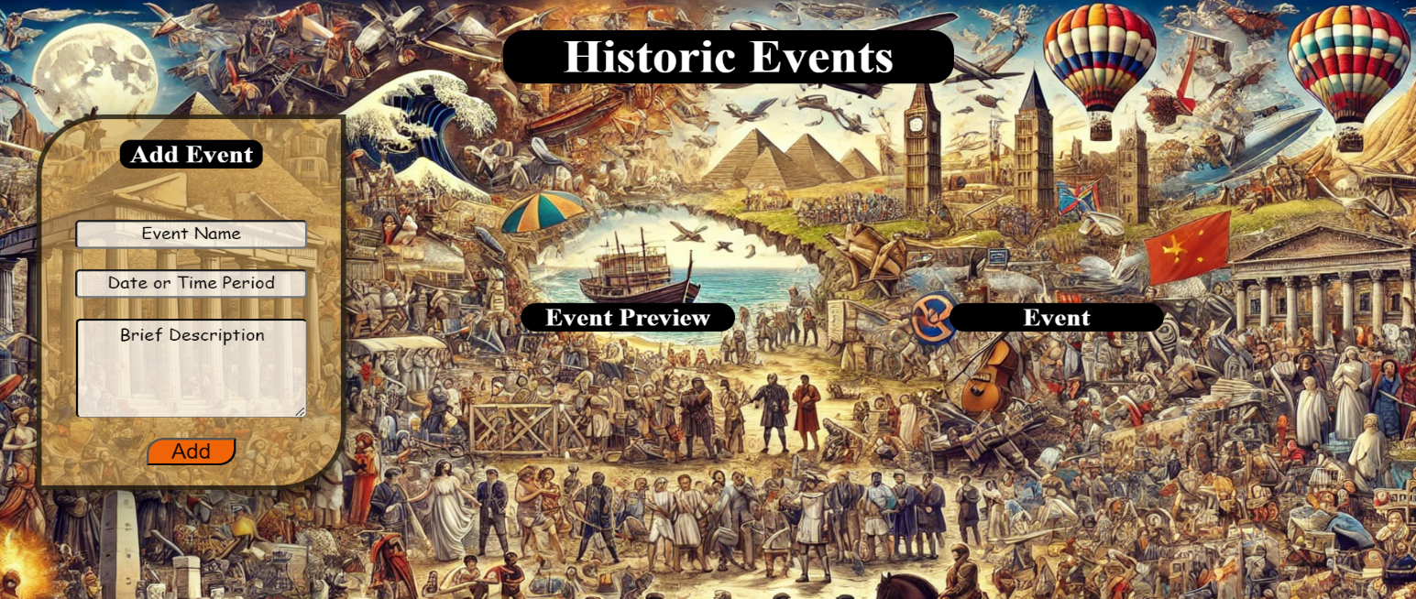

# Submission

Submit only your **solve()** function.